# Difficult Passages

Keener, Chapter 2 & 3, The Bible in Its Context

Bailey, Jesus through Middle Eastern Eyes

Carsons, Exegetical Falacies

**Parables: What is the Point?**

[Bailey, Jesus through Middle Eastern Eyes]

Chiasm/Parrallelism, structured rhetoric, contrasts,...

Jesus was a metaphorical theologian and taught in parables. “His primary method of creating meaning was through metaphor, simile, parable and dramatic action rather than through logic and reasoning. He created meaning like a dramatist and a poet rather than like a philosopher….A metaphor communicates in ways that rational arguments cannot. ” [Bailey, 279-280].

Where is the point? "In its Middle Eastern setting, as a minidrama the parable is filled with questions, surprises and passions. But the ending is missing. Do the complaining em- ployees [paid the same in the vineyard] obey the master’s command by taking their pay and leaving, or do they opt to continue shouting at him demanding more? We are not told, just as we do not know what the older son will do at the conclusion of the parable of the prodigal son (Lk 15:24-31) or what will happen to the good Samaritan when he walks out of the inn (Lk 10:25-37)." [Bailey, 357]

One point? "If the great parable of the prodigal son has “only one point,” which shall we choose? Should the interpreter choose “the nature of the fatherhood of God,” “an understanding of sin,” “self-righteousness that rejects others,” “the nature of true repentance,” “joy in community” or “finding the lost”? All of these theological themes are undeniably present in the story and together form a whole that I have called 'the theological cluster.’” [Bailey, 282]

**The Parable of the Vineyard** (Matt 20:1-16) [356]

- Compassion- it shows compassion for the unemployed. He returns five times (the manager’s job), why not just hire them all in the morning? He goes back to the unemployment line and offers work to those who have not been hired yet. Why would anyone still be there around 5pm; they were desperate and hoping.

-Grace - he pays the most gracious sums (overpaid) in front of everyone. In this parable, units of work and payment amount are not linked.

-*The missing ending:* The parable reaches a critical dramatic moment and stops. What is the response of the workers who are complaining? We are not told.

**Unjust Steward** (Luke 16:1-8) [screenshot]

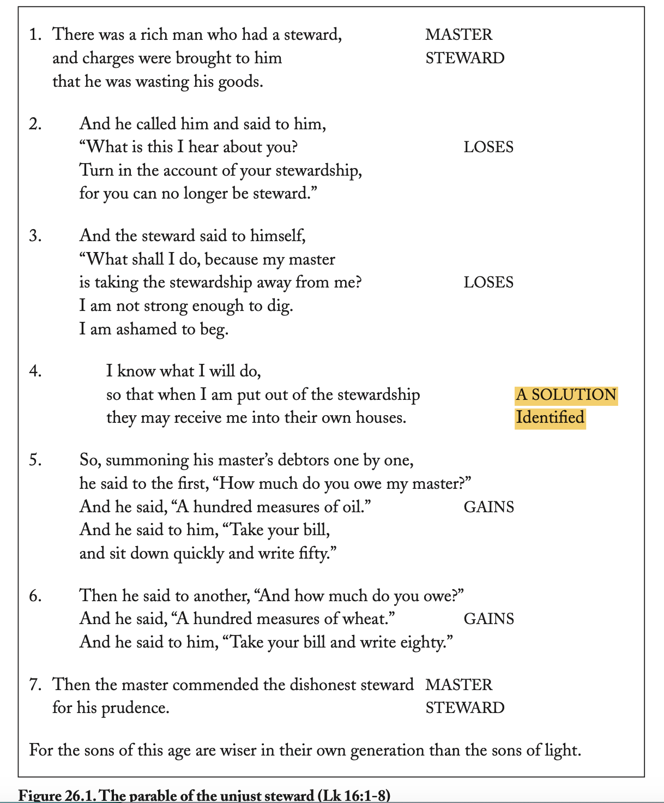

**Jesus the Good Shepherd** (John 10:11-15) [screenshot]

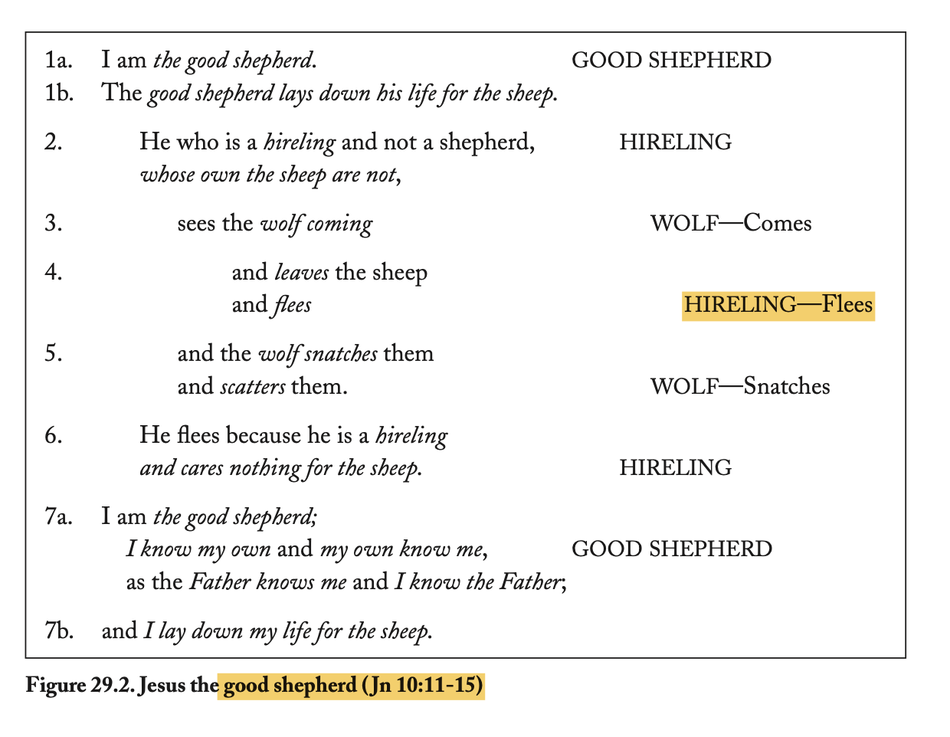

**Epistles - What are the Principles?**

"Paul works with ideas *and* metaphors.” [Bailey, 280]. "Many Christians today question the faith of others who do not interpret literally every text that we interpret literally; yet all of us refuse to take some texts literally—or at least we refuse to apply some texts directly to ourselves without taking into account that our situation is different….In fact, *all* Scripture is universally applicable (2 Tim 3:16)… it means that we have to take the situation into account when we interpret Scripture, reading it like case studies applying to specific situations to find its **principles** which we can then apply in other situations." [Keener, 121]

"Some today seek to get doctrine especially from Paul’s letters... Paul tells Timothy to go to Troas and bring his cloak from there (2 Tim 4:13), yet none of us tries to obey this explicit command of Scripture by going to the excavations at Troas and looking for Paul’s cloak...This passage of Scripture is addressed to the only person who could fulfill it, namely Timothy.” [Keener, 120]

* Do we really need to beware of Alexander the coppersmith (2 Tim 4:14-15)
* How many Christians put money into savings the first day of every week for a collection for the saints in Jerusalem (1 Cor 16:1-3)?
* Paul commands his readers to receive Epaphroditus (Phil 2:29)
* **“**likewise also that women should adorn themselves in respectable apparel, with modesty and self-control, **not with braided hair** and gold or pearls or costly attire” (1 Tim 2:9). So what about all those little girls at church with braided hair? And the ancient culture unbraided hair was a sign of rebellion. Mounce says it may be the translation problem that “not with braided hair **and** gold or pearls,” meaning they were braiding and putting gold and pearls in their hair. <https://zondervanacademic.com/blog/can-women-braid-their-hair-1-tim-29>
* Paul exhorts his readers to pray for the ministry of himself and his companions (2 Thess 3:1-2)
* **Cultural references,** not doctrine (laws), what is the theme? Culturalisms do not travel. -older widows washing feet, eldership structure, household rule…
* How many would regard as transcultural the warning that widows younger than sixty will spread bad talk (probably best translated “false teaching”; 1 Tim 5:11- 13), or that fables circulate especially among older women (4:7)? Here, for example, widows must not be put on the roll for church support unless they are at least sixty years old, have been married only once (5:9), have raised children and **washed strangers’ feet** (5:10), and also have no extended family to care for them (5:8).
* Young widows must remarry… In Paul’s day there was a shortage of women (possibly due to the pagan practice of female child abandonment), and most women therefore sought and found husbands quickly. In many black American churches, however, **single women outnumber single men more than two to one**; in parts of rural India and China, by contrast, men far outnumber women.
* his exhortations concerning the **obedience of slaves** (1 Tim 6:1-2; cf. Tit 2:9-10), which most Christians today would grant addressed a specific cultural situation.
* When Paul exhorts men to pray properly (1 Tim 2:8), shall we assume that women should not pray properly? Or shall we assume that, just as Paul had a specific situation to address with the women in that congregation (2:9-15), he also had a specific problem in mind addressing the local men’s behavior (2:8)?
* The office of an “overseer” (1 Tim 3:1), like most other local-church offices in the New Testament, arose in a specific cultural context; it was practical for the church to borrow models of leadership from the synagogues that already worked in the Roman world. Is it possible that modern denominations’ arguments about forms of church leadership may make too much of a matter that is not really central to Paul’s point?
* Using the past point for us Today. Paul specifically left Timothy in Ephesus to warn against those teaching false doctrines (1 Tim 1:3), and exhorts Timothy to do so according to the prophecies given him (1:18; 4:14; cf. 2 Tim 1:6); he also addresses specific false teachers (1:20), who are now dead. Although Paul did not leave us in Ephesus nor did we receive Timothy’s prophecies, there are plenty of transcultural principles here, such as fighting dangerous doctrines, or heeding words of wisdom or properly tested prophecy.
* Paul tells Timothy to drink a little wine for his stomach’s sake (1 Tim 5:23), we learn that it is sometimes necessary to take medicine.
* When Paul says to “Greet one another with a holy kiss” (Rom 16:16; 1 Cor 16:20; 2 Cor 13:12; 1 Thess 5:26), he uses the standard form of intimate greeting in his culture.
* murmuring is always wrong (1 Cor 10:10; Phil 2:14);
* eating idol-food is sometimes wrong (1 Cor 8-10);
* women’s authority as ministers of the word was sometimes limited but sometimes commended (cf. Rom 16:1-12; Phil 4:3).
* Given other passages which commend (Rom 16:1-12; cf. Judg 4:4; Acts 2:17-18; 21:9; Phil 4:2-3) or permit (1 Cor 11:4-5) various ministries of women, is it possible that the limitations of 1 Tim 2:11-12 address a special situation?

Romans 7-8 - Romans 7 is notoriously viewed as a the struggle of the Christian between their old and new nature. But Paul is speaking about life under the law (in the first person) and the change to the new life in the Spirit. All Christians are sealed and have the Holy Spirit. Paul is warning against legalism (which in Hebrews is described as apostasy or leaving the faith).

**Book of Hebrews**

*inspiration from both NET and Luke Timothy Johnson’s commentary

7 “better than” statements of Christ (blue), followed with warnings against apostasy (purple)

| 1:1-4 Introduction about the Son  1:5-14 The Son is Better Than the Angels   * 2:1-4 Warning against apostasy * 2:5-18 Psalms 8 and Jesus’ concern for humans   3:1-6 The Son Is Better Than Moses   * 3:7-19 Psalms 95 - Warning against apostasy * 4:1-13 Enter the Sabbath rest of God and not apostasy   4:14-5:10 Jesus, the High Priest, Better than earthly priests   * 5:11-6:12 Exhortation to maturity and warning against apostasy * 6:13-20 God’s Promise to Abraham * 7:1-10 Abraham priesthood is lesser than Melchizedek   + 7:11-19 Jesus of the better Melchizedek priesthood   8:1-6 The Son Is the Mediator of a Better New Covenant   * 8:7-13 The Promise of a New Covenant * 9:1-10 The Worship of the Old Covenant   9:11-28 Christ the Better Sacrifice   * 10:1-18 Old and new sacrifices compared * 10:19-31 warning against apostasy * 10:32-39 remember your endurance and continue   11:1-40 Christ’s Faith is Better   * 11:1-40 The Faith of the Ancients, Patriarchs,Moses and the Israelites, Many Witnesses * The perfect faith of Jesus * 12:1-17 Join the Endurance of Faith (and not apostasy)   **12:18-29 Conclusion: The new covenant is better than the old covenant. Join the spiritual people with celebratory angels and the church through Christ’s better sacrifice (v25-29 and do not apostatize by refusing his voice).**   * 13:1-17 Final instructions: invest in loving people and relationships * 13:18-25 Final Prayer and Greeting |
| --- |

**Acts**

Gentile inclusion and the new covenant marked by prophecy. Not doctrine on how to receive the Baptism of the Holy Spirit or tongues as initial evidence.

**OT**

Narratives, not commentary. Not morality. (Is polygamy sanctioned?)

Those events were written down as examples for us, both positive and negative (1 Cor 10:6, 11) [Paul uses them as case studies]. In the same way, we should read the stories in the Bible as case studies—as examples how God dealt with people in particular kinds of situations.

* God destroyed the disobedient in the wilderness (1 Cor 10:6-10); that does not mean that *obedient* people should fear destruction!

**Psalms**

Poetry, hyperbole, allusion, figurative language.

Hard Passage 23: **Does Psalm 18:7-15 refer to Jesus’ second coming? (Read 18:4-6, 16-19.)**

"The language of Psalm 18:7-15 **sounds like a cosmic event** that shakes all of creation. But ancient Israelite songs, like some of our songs today, could express praise poetically. In this case, the psalmist describes a time when **God delivered him personally** (18:4-6, 16-19). The deliverance sounds like it affects all creation, but in fact it reflects the dramatic experience of the psalmist, from whose perspective God’s intervention seemed too dramatic to narrate in any less cosmic manner.” [Keener, 63]

**Proverbs**

True in general, but not specifically.

Do you answer a fool or not? “Do not answer a fool according to his folly, or you yourself will be just like him. Answer a fool according to his folly, or he will be wise in his own eyes.” (Prov 26:4-5)

**Revelation**

Allegory? Literal? What parts?

* Is Babylon literal? - Peter calls Rome the Babylon of his day (1 Pet 5:13)
* Is 1000 or 10000 meant to be literal? 10000 from each tribe? 1000 year time period (millenium); is it a literal 1000 years? Everywhere else in the Bible 1000 is used not as an exact number but a symbolic quantity.
  + Samson kills 1000 Phillistines with the jawbone of a donkey. (Judges 15:15 - 16). Did he count to exactly 1000?
  + “May the Lord, the God of your fathers, make you a thousand times as many as you are and bless you, as he has promised you!” Deut 11:1
  + He also reminded the people that God's blessings and mercy are guaranteed, to a thousand generations, toward those who love and obey him (Deut 7:9; Ps 105:8).
  + God promises, to those who do His will, that they will be divinely protected. One person will be able to chase away one thousand while countless others who attack will fall and cause them no harm (Joshua 23:10, Psalm 91:7).
  + a prophetic day can be 1000 years in human history.
  + “For a thousand years in Your sight are as yesterday when it is past, and as a watch in the night” (Psalm 90:4).
  + “with the Lord, one day is as a thousand years” (2Peter 3:8).
  + “Then I saw an angel descending from heaven, … And he took hold of the dragon, the ancient serpent, who is the Devil and Satan, and bound him for a thousand years. … so that he would not deceive the nations any longer until the thousand years were fulfilled“ (Rev 20:1 - 3).
  + **“**Also I saw the souls of those who had been beheaded for the testimony of Jesus and for the word of God, and those who had not worshiped the beast or its image… They came to life and reigned with Christ for a thousand years” (Rev 20:4). “Blessed and holy is the one who shares in the first resurrection! Over such the second death has no power, but they will be priests of God and of Christ, and they will reign with him for a thousand years” (Rev 20:6).

## Hard Passages

**12. When Paul says, “I can do all things through Christ who strengthens me”(Phil.4:13), does he have anything in particular in mind? (I.e., does “all things” mean that he can currently fly, walk through walls, spit fire, and so forth, or does it mean something more specific?)**

A football player assumed that “do all things” meant winning games because he was in Christ. The context is "thanking the Philippians for sending him a love-gift (4:10, 14), Paul noted that he had learned contentment with both little and with much (4:12); he could do all things through Christ (4:13). In this context, he is saying that by Christ’s strength he could rejoice whether he had much or little. Today we should learn to rejoice in whatever our situation, knowing that Christ strengthens us to endure: whether persecution, ridicule, or even losing a football game.” [Keener, 55]

**13. “Faith comes by hearing, and hearing by the word of God.” (Romans 10:17). What is the “word of God”? Does this mean quoting Scripture to gain faith for anything?**

This verse is particularly refering to the “word of God” which is the gospel message as the surround passage points out. “Paul argues that no one could be saved unless they heard this word, which is the message of Christ (10:14- 15), the “report” of the witnesses (10:16). This is also the “word” in their mouths and hearts through which they are saved (10:8-10). Faith could only come from hearing this word, the gospel of Christ (10:17). In contrast to Hebrews 11:1, where “faith” in context means persevering faith, this passage refers to saving faith. One cannot be saved until one hears the truth about Jesus.” [Keener, 56]

14. **1 Corinthians 13:8-10. Some people quote this passage to claim that spiritual gifts have passed away.**

"Paul says that spiritual gifts like prophecy, tongues and knowledge will pass away when we no longer need them (1 Cor. 13:8-10). Some Christians read this passage as if it said, “Spiritual gifts like prophecy, tongues, and knowledge passed away when the last book of the New Testament was written.” This interpretation of 1 Corinthians 13 ignores the entire context of 1 Corinthians, however: it is a letter to the Corinthians in the middle of the first century, and they had never yet heard of a New Testament in the middle of the first century. Had Paul meant the completion of the New Testament, he would have had to have made this point much more clearly—starting by explaining what a New Testament addition to their Bible was.” [Keener, 56]

**15.** Hebrews 11:1 declares that “**Now faith** is the substance of things hoped for, the evidence of things not seen.”

"Now-faith" is sometimes preached (“now" as an adjective). But here “now” is an adverb (much like “but” or “and”). The reward of this passage and context is in the future, not the present. The passage is about enduring faith that lasts through suffering (Heb. 10:32-34).

***16. Jesus knocking at the door in Revelation 3:20. Is Jesus knocking on unbeliever’s hearts in this verse trying to get them to convert?***

Here Jesus knocks not at the door of the individual sinner, but rather at the door of a church that was acting like one! Whereas Jesus had set before another church an open door, inviting them into his presence despite the false accusations of their persecutors (Rev 3:8), he was here locked out of another church. He wanted these Christians to repent and express again their need for him (3:19). The idea of Jesus knocking on the door of sinners hearts (or better pursuing the one lost lamb) is found in other passages, just not this verse.

**17. “For God so loved the world that he gave his only begotten Son...” (John 3:16). When was the Son given?**

When Jesus was lifted up (3:14-15) meaning the cross when He died. This is not specifically refering to Bethlehem or when Jesus was raised from the dead.

**18. Are all believer’s Christ’s ambassadors in 2 Cor 5:20?**

Ideally, all Christians should be Christ’s ambassadors but in this passage Paul is refering to a particular situaiton that need reconciling. The “we” in this passage being referred to is Paul and his ministry companions. 'After all, those he is entreating to be reconciled to God are the Christians in Corinth, who are not ambassadors but those who need ambassadors to them (6:1-2).” (Paul may be using hyperbole, a figure of speech that means “rhetorical overstatement to graphically emphasize a point”).

**21. Some people claim the promise that no weapon formed against them would prosper (Isaiah 54:17). Is this a guarantee for every individual Christian in every circumstance or for God’s people as a whole protected by His plan for them?**

The context indicates that the passage focuses on God’s people. Israel had sinned, been judged, but now would be restored, and those who had tried to oppose Israel would be crushed. There is a principle here that God vindicates his people; but it is not an ironclad guarantee for every circumstance in the short run for each individual (though he often does provide protection for Christians, he does not do so all the time; many Christians have died as faithful martyrs). It does encourage us, however, that God will ultimately vindicate his servants and his plans for history. [Keener, 62]

**25a. In Matthew 18:18, what does Jesus mean by “binding and loosing”? Does He refer to how to treat demons here, or does He refer to something else? (Read especially 18:15-20.)**

I used to follow a popular misinterpretation of this verse... to “bind” and “loose” demons whenever I would pray. But one day I read Matthew 18:18 in context, and I realized that I had been misinterpreting the passage. [The idea of rebuking or resisting evil is found in other passages, so that practice should continue.] … When Jesus claims to have “bound the strong man” (Matt 12:29), he does not first tell Satan, “I bind you” before casting out demons. He had already defeated the strong man by overcoming temptation and obeying the Father’s will; thus He was free to exercise His authority and cast out demons.

What do “binding” and “loosing” mean in this context? In the context, Jesus indicates that if one’s fellow-Christian is living a sinful lifestyle, one must confront that Christian; if he or she refuses to listen, one should bring others so one will have two or three witnesses if one must bring the matter before the church. If despite repeated loving confrontations that person refuses to repent, the church must put that person out of the church to teach the person repentance (Matt. 18:15-17). In this context, Jesus declares that whatever they “bind” or “loose”on earth will have already been “bound”or “loosed” in heaven—i.e., under these circumstances, they clearly act on God’s authority (18:18). Because the terms “binding” and “loosing” literally have to do with imprisoning or releasing people, and Jewish teachers used these terms to describe their legal authority, the terms make good sense in this context: the church must discipline its erring members, removing them from participation in the church if they continue in unapologetic sin.

**25b. In Matthew 18:19, why do two or three need to gather to pray? Is this to pray about anything in general?**

The “two or three” who pray in this context (18:19) refer to the two or three witnesses (18:16). But this verse does not imply that prayer is efficacious only for a minimum of two persons; it promises that even if only two witnesses are available, and even if the prayers or actions on earth involve something as serious as withdrawing a person from the church, God will back up His servants whom He has authorized…. Perhaps the specific prayer in mind is a prayer that God will bring the disfellowshiped person to repentance and restoration; if so, Jesus deliberately contrasts the attitude required of His followers with the two or three witnesses in the Old Testament law, who were to be the first to stone those against whom they testified (Deut. 17:7).

26. **What is the “coming” to which Jesus refers in John 14:1-3? Does He refer here to His second coming or to something else? (Read 14:4-23, and perhaps 13:36-38.)**

Jesus tells His disciples, “In my Father’s house are many **‘dwelling-places’”** (14:2; “mansions” comes from the Latin translation—it is not in the original Greek text). Jesus promises that He is going to prepare a place for His disciples, but will return and take them to be with Him where He is (John 14:2-3). Usually readers today assume that Jesus here refers to his future coming to take us to heaven or the new earth [second coming]. But the context indicates that Jesus is speaking of an *earlier* coming here... being with him in our daily lives in the present.

Peter wants to follow Jesus wherever He goes, but Jesus tells him that if he wants to follow Jesus where He is going, he must follow Him to the death ( John 13:31-38). Nevertheless, Peter and the other disciples should not be afraid; they should trust in Jesus the same way they trusted in the Father (14:1). He would prepare a dwelling-place for them in His Father’s house, and would come back afterwards to receive them to Himself (14:2-3). “You know where I’m going and how I will get there,” He told them (14:4). Perhaps like us, the disciples were confused, and Thomas spoke for all of them: “Lord, we don’t even know where You’re going; how can we know the way you’re getting there?” (14:5) So Jesus clarifies His point: Where He is going to the Father (14:6), and He is going there by dying on the Cross but would return afterward to **give them the Spirit** (14:18-19; 16:18-22). How would they get to the Father? By coming through Jesus, who is the way (14:6).

We often cite John 14:2-3 as a proof-text for Jesus’ future coming; conversely, we cite John 14:6 as a proof-text for salvation. But if we follow the flow of conversation, we have to be wrong about one of them. 14:2-3 declares that Jesus will bring them where He is going, but 14:6 tells us where He’s going and how we His followers will get there: He is going to the Father, and we come to the Father when we get saved through Jesus (14:6). Do we come to the Father through Jesus only when He returns in the future, or have we come to Him already through faith? The entire context makes this point clear. **We enter the Father’s house when we become followers of Jesus Christ!**

In the context of John’s entire Gospel, there is no reason to assume that the “Father’s house” refers to heaven, though it might be an allusion to the Temple (John 2:16) or to the Father’s household (John 8:35; and **we are His new temple and His household**). More helpfully, Jesus goes on to explain the “dwelling-places” (niv: “rooms”) explicitly in the following context. The Greek word for “dwelling- place” used in 14:2 occurs in only one other verse in the New Testament—in this very context, in 14:23, part of Jesus’ continuing explanation of 14:2-4. “The one who loves Me will obey Me, and My Father will love that one and we will come make our ‘dwelling-place’ with that person” (14:23). The related verb appears throughout John 15:1-10: “Dwell [abide]” in Christ, and let Christ “dwell” in you. We all know that Jesus will return someday in the future, but if we read the rest of John we learn that Jesus also returned to them from the Father after His resurrection, when He gave the disciples the Spirit, peace and joy (20:19-23), just as He had promised (14:16-17, 26-27; 16:20-22). This is in fact the only coming the context addresses (14:18 in the context of 14:15-27; 16:12-24).

What is the real point of John 14:2-3? It is not that Jesus will return and we will be with Him someday—true as that teaching is from other texts. It is that Jesus returned after His resurrection so Christians could have life with Him (14:18-19), that He has already brought us into His presence and that we can experience the reality of His presence this very moment and at all times. This means that the same Jesus who washed his disciples feet in the preceding chapter, who taught and healed and suffered for us, is with us at this very moment. He invites us to trust His presence with us.